- The U&ME-A Programme sounds like it might be something I would like to apply for. What next?
If you are interested in attending this training programme,
- You may be referred by your doctor or you may self-refer to Arbour House for an initial assessment.
- After this, you will be offered an appointment with an individual therapist from the U&Me-A programme.
- This appointment will involve pre-screening to determine if this programme is best suited to your needs at this time.
- During this initial appointment the therapist will give you further information about the programme and ensure that you are willing to fully engage.

- You may be asked to complete a number of assessment measures either during this initial appointment or during the first group session of the programme.
Contact a member of staff for further information.

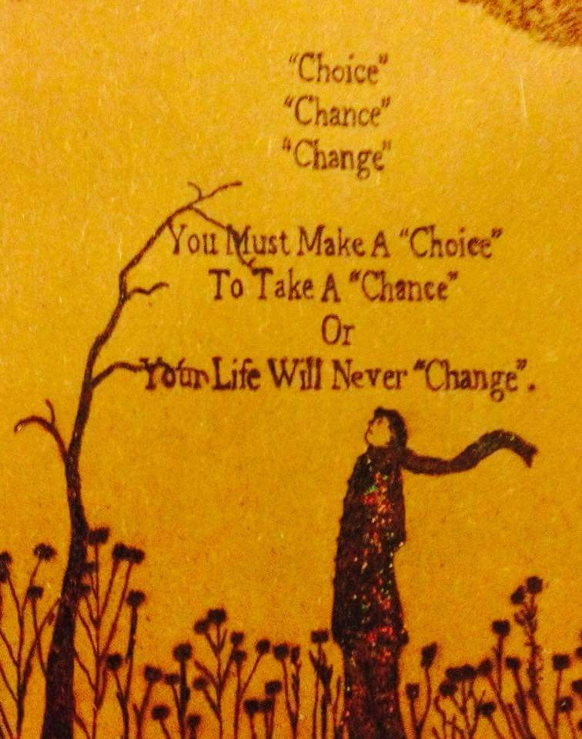

Understanding & Managing Emotions – Addiction Program

hSAS
[HSE South Addiction Service- ‘Caring for people affected by Addictions’]
Arbour House
St Finbarr’s Hospital
Douglas Rd.
Cork
Tel: 021-4968933
- What is the U&ME-A programme?
Understanding and Managing Emotions – Addiction (U&ME-A) is a group programme based on skills taught in Dialectical Behaviour Therapy (DBT).
U&ME-A aims to teach you how to increase your awareness of your emotions and skills to deal with them more effectively.
The programme covers 3 modules over 24 weeks (8 weeks each). You will be required to sign up to all modules.

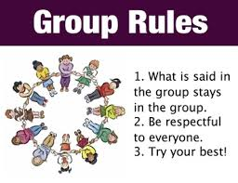
- What does the U&ME-A programme involve?
Each session will be 2.5 hours. These sessions will assist you in learning how to:
- Be more aware of your thoughts, feelings and actions and how they impact on your behaviour (Mindfulness skills).
- Build skills to cope more effectively in managing stressful life events, coping in a way that is less destructive to you and your relationships (Distress Tolerance).
- Practice skills in understanding and managing your emotions (Emotion Regulation).
- Improve your ability to relate to people and to feel more skilled and confident in doing so (Interpersonal Effectiveness).

- Who might be best suited to this Program?
- Adults who are looking for help with managing both addiction and Mental Health concerns.
- Who are currently engaged in alcohol or drug abuse.
- Who are motivated and ready for change.
- Who have an up-to-date report & support from Doctor or Mental Health team.

